TRAN CAO VAN PRIMARY SCHOOL  CLASS: 3/………………  NAME: …………………………………………. | REVISION  Time: 30 minutes  Test 5

Question 1: Look and read. Put a () in the box.
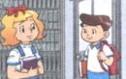
Example:
0. How are you?
 A. I’m Linda.
 B. I’m fine, thank you.
 C. Nice to meet you.

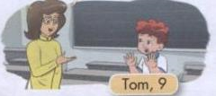
1. How old are you, Tom?
 A. Hi. I’m Tom.
 B. I’m nine.
 C. This is Tom.

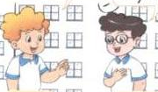
2. What’s your name?
 A. My name’s Nam.
 B. It’s Nam.
 C. Hello, Nam.

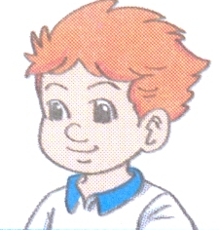
3. Who’s that?
 A. Yes, he is.
 B. It’s Tony.
 C. He isn’t Tony.

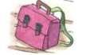
4.
 A. This is my school bag.
 B. This is my pencil sharpener.
 C. This is my pencil case.


5. What colour are your rubbers?
 A. They are green.
 B. It’s green.
 C. Yes, they are.

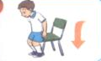
6.
 A. Be quiet, please!
 B. Stand up, please!
 C. Sit down, please!

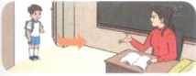
7.
 A. Open your book, please.
 B. May I come in?
 C. May I go out?

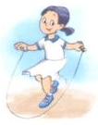
8. Do you like skipping?
 A. I like skipping.
 B. Let’s play skipping.
 C. Yes, I do.

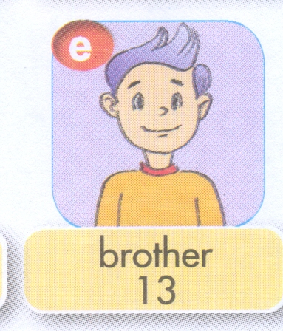
9. How old is your brother?
£ A. She’s thirteen
£ B. He’s thirteen
£ C. He’s thirty

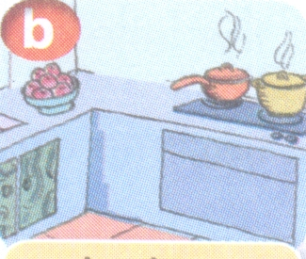
10.
£ A. This is my kitchen.
£ B. This is my living room.
£ C. This is my bathroom.

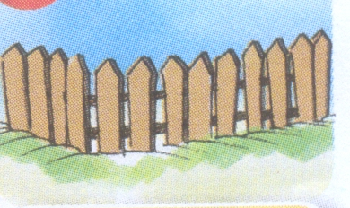
11. Is there a fence?
£ A. Yes, there is.
£ B. No, there isn’t.
£ C. Yes, there isn’t.

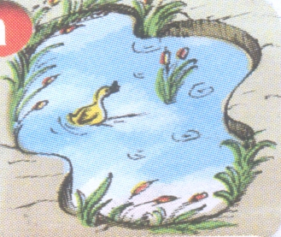
12.
£ A. There is a gate.
£ B. There is a pond.
£ C. There is a yard.

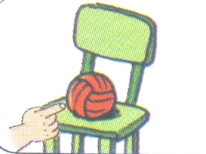
13. Where’s my ball ?
£ A. It’s here.
£ B. It’s there.
£ C. It’s my ball.

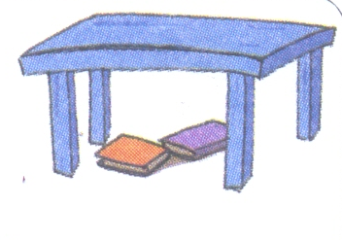
14.
£ A. There are two books near the table.
£ B. There are two books behind the table.
£ C. There are two books under the table.


15.
£ A. It is sunny.
£ B. It is cloudy.
£ C. It is rainy.
Question 2: Look and read. Write Yes or No on the line.

0. 1. 2.
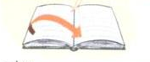
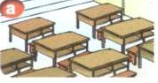
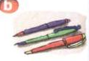

Close your book, please. That is the gym. These are pens.
Yes _____ ____

3. 4. 5.
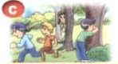
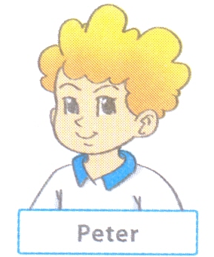
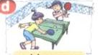

Let’s play blind man’s bluff. My name’s Tony. I play table tennis.
_______ _______ ______

6. 7. 8.
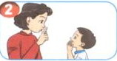
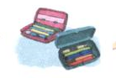
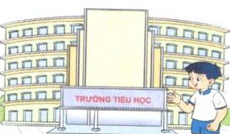

Be quiet, please!. Those are my notebooks. The school is big.
_____ ______ ______

Question 3: Look at the pictures and the letters. Write the words.
1. 2. 3.
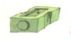
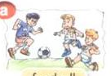
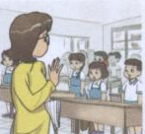

sh_rpe_er f_otb_ll b_ _

4. 5. 6.
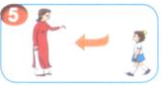



c_m_ here. c_mp_ter room _ _bbers

Question 4: Fill in each gap with a suitable word from the box.
what, Hi, play, like, don’t, do, you

Peter: (0) Hi, Tony. (1) ______________ do you do at break time?
Tony: I (2)_______________ badminton.
Peter: Do you (3)________________ it?
Tony: Yes, I (4)________________.
Peter: Do (5)_____________ like blind man’s bluff?
Tony: No, I (6)_______________.
Question 5: Reorder the words to make sentences.
Example: are/ How/ you/ ?/
How are you?

1. spell/ do/name/his /how/you?

-----------------------------------------------? .
2.his/ name / is/ what?

-----------------------------------------------? .
3. this/ Miss Lan/ is?

-----------------------------------------------? .
4. Mr / is/ that/ Loc/.

-----------------------------------------------.
5. she/ old/how/ is/?

-----------------------------------------------? .
6. twelve/ Mai / years / is / old/.

----------------------------------------------- .
7.Peter/ / Mary / her/ are/ and / friends ?

-----------------------------------------------? .
8.out/ may/ go/ I?
-----------------------------------------------? .
9.computer/ room/ is/ old/ the.
----------------------------------------------- .
10. his/ are/ those / pencils?

-----------------------------------------------? .
11. colour/ they/ what/ are?
-----------------------------------------------? .
12.brother/ old/ fifteen/ years/ is/ my.
----------------------------------------------- .
13.pond/ over/ a/ there/ there/ is.
----------------------------------------------- .

Question 6: Look and read. Write Y (Yes) or N (No) as examples.
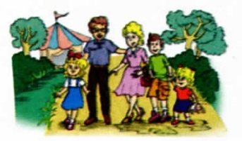

This is a photo of my family. Look at the man. He is my father. He is forty years old. The woman next to him is my mother. She is thirty- nine years old. The boy is my brother. He is fourteen years old. He is young. And the little girl is my sister. She is five years old. Can you see me? Yes, my name is Linda. I’m eight years old.
Neeeeeees

0.This is a photo of a school.

Y
00.This is a photo of a family.

1. The man is fourteen.

2. The woman is behind the man.

3. The woman is thirty- nine years old.

4. The boy is old.

5. The boy is fourteen years old.

6. The little girl is five years old.

7. Linda is a boy.

8. She is eight years old.

KEYS
Question 1: Look and read. Put a () in the box.
1.B 2.A 3.B 4. A 5. A 6. C 7.B 8. C 9.B 10.A
11. A 12.B 13.A 14. C 15. A
Question 2: Look and read. Write Yes or No on the line.
1.NO 2. YES 3. NO 4. NO 5. YES 6. YES 7. NO 8. YES
Question 3: Look at the pictures and the letters. Write the words.
1. sharpener 2.football 3. bye 4.come here 5. computer room 6. rubbers
Question 4: Fill in each gap with a suitable word from the box.
1. What 2. play 3. like 4. do 5. you 6. don’t
Question 5: Reorder the words to make sentences.
1. How do you spell his name?
2 What is his name?
3.Is this Miss Lan?
4. That is Mr Loc.
5. How old is she?
6. Mai is twelve years old
7. Are Peter and Mary her friends?
8. May I go out?
9. The computer room is old.
10. Are those his pencils?
11. What colour are they?
12.My brother is fifteen years old.
13. There is a pond over there.

Question 6: Look and read. Write Y (Yes) or N (No) as examples.
1.N 2. N 3. Y 4. N 5. Y 6. Y 7. N 8. Y

