TRAN CAO VAN PRIMARY SCHOOL  CLASS: 4/………………  NAME: …………………………………………. | English test  Time: 30 minutes  Test 3.

Question 1. Look and write:
1.
  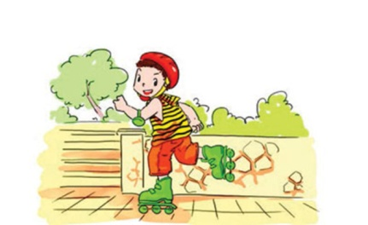 |  | 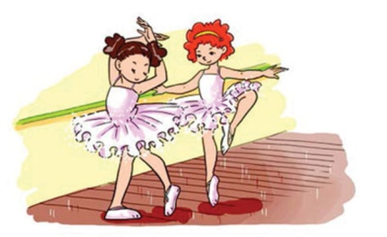
  A. ____________________ |  | B. ____________________
2.
  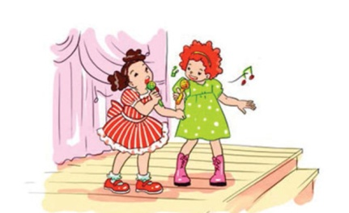 | 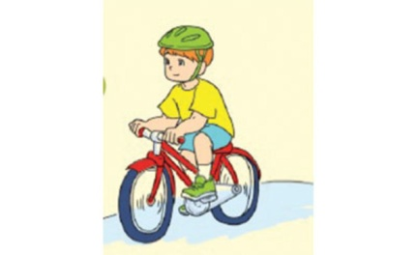
  A. ____________________ | B. ____________________
3.
  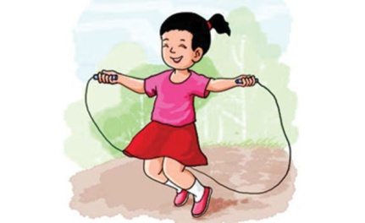 | 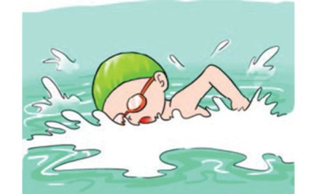
  A. ____________________ | B. ____________________
4.
  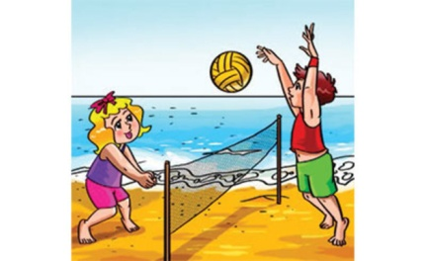 | 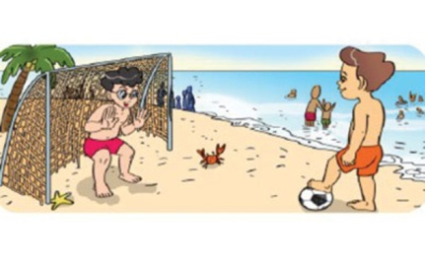
  A. ____________________ | B. ____________________
5.
   | 
  A. ____________________ | B. ____________________

Question 2: Look and read. Put the correct word in each line.
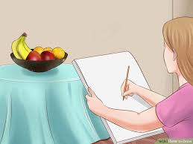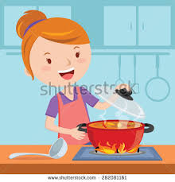
Skate Draw Playing badminton Cooking
1. Mai likes … at break time. ____________________
2.We usually … during Art lesson. ____________________
3.He can’t …. ____________________
4.My mother likes …. ____________________
Question 3: Read the text. Fill in the blanks in the table.
- Hi, my name is Linda Wales. I live in Hanoi but I’m Australian. I’m nine years old. My school is in Cau Giay District. I love studying Maths and Art. My favourite sports is playing badminton and listening to music at free time.
- Hello, I’m Jack Brown. I come from England and I study at Ba Dinh Primary School. It’s in Ba Dinh District. I like skating and playing football with my friends at break time.
 |  | 
First name | (1)……………….. | Jack
Nationality | Australian | (2)……………………
Hobby | playing badminton and (3)……………………. | skating and (4)……………………

Question 4: Look and write .

 | 1.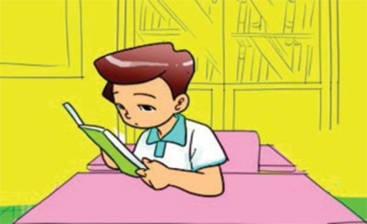 | 2.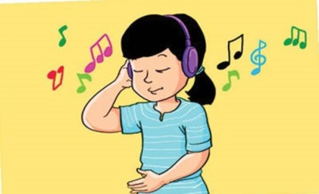

  3. 
  .
  4.
  5.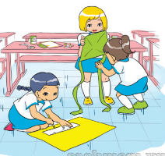
  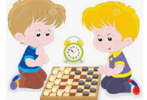
1/ He is reading a book.
2/ ______________________________________________________________________.
3/ ______________________________________________________________________.
4/ ______________________________________________________________________.
5/ ______________________________________________________________________.
6/ ______________________________________________________________________.
Question 5: Fill in the blanks.
1. He’s reading a book __________ the classroom.
2. Let’s __________ football, Tom.
3. She’s __________ a dictation.
4. He is in the computer __________.
5. __________ are the pupils doing in the classroom?
6. __________ the red table, they are drawing pictures.
7. They’re making a __________ plane/ boat.
8. He’s making __________ kite.
9. Are they having __________ Art lesson?
10. The girls are playing badminton __________ the playground.
11. She’s looking __________ the mask.
12. We are having __________ break.
13. He’s __________ exercise in the classroom.
14. Linda and Mai __________ playing volleyball.
15. We are having a __________ of fun here.
Question 6: Reorder the words to make sentences.
1. are/ Quan/ making/ and/ paper/ Phong/ planes
______________________________________________________________________.
2. She/ in/ exercise/ the/ is/ playground/ doing
______________________________________________________________________.
3. is/ He/ in/ painting/ his/ picture/a/ room
______________________________________________________________________.
4. the/ are/ The/ puppet/ a/ girls/ making/ classroom/ in
______________________________________________________________________.
5. Are/ a/ having/ they/ lesson/ Music?
______________________________________________________________________.
6. reading/ What/ you/ are/?
______________________________________________________________________.
7. play/ Let’s / guitar/ together/ the
______________________________________________________________________.
8. here/ We/ having/ of/ a/ are/ fun/ lot
______________________________________________________________________.
9. a/ are/ break/ We/ having
______________________________________________________________________.
10. He/ reading/ is/ text/ a
______________________________________________________________________.
The End

TRAN CAO VAN PRIMARY SCHOOL  CLASS: 4/………………  NAME: …………………………………………. | English test  Time: 30 minutes  Test 4
Question 1: Look and write about where someone was in the past:
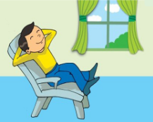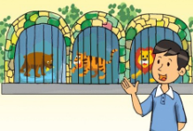
1 2 3
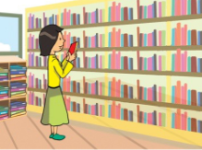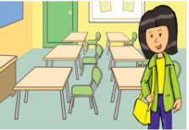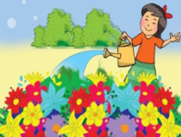
4 5 6

1/ He was at home yesterday.
2/______________________________________________________________________.
3/______________________________________________________________________.
4/______________________________________________________________________.
5/______________________________________________________________________.
6/______________________________________________________________________.
Question 2: Look and write about what someone did in the past:
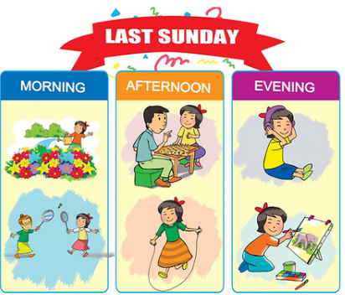
1/ She watered the flowers last Sunday morning.
2/ ______________________________________________________________________
3/ ______________________________________________________________________
4/ ______________________________________________________________________
5/ ______________________________________________________________________
6/ ______________________________________________________________________
Question 3: Circle the odd one out:

1. a. morning b. evening c. dancing d. afternoon
2. a. tomorrow b. night c. yesterday d. today
3. a. see b. meet c. watch d. again
4. a. hello b. goodbye c. good morning d. good afternoon
5. a. Japanese b. Australia c. America d. England
6. a. Austalian b. Malaysian c. Vietnamese d. America
7. a. Wednesday b. Yesterday c. Saturday d. Tuesday
8. a. on b. sit c. in d. to
9. a. what b. want c. where d. how
10. a. February b. Library c. March d. July
11. a. May b. April c. Ninth d. June
12. a. twenty b. twenty-third c. twenty-three d. twenty-nine

13. a. ride b. bike c. swim d. swing
14. a. dictation b. write c. comic book d. text
15. a. tennis b. football c. guitar d. volleyball
16. a. classroom b. teacher c. gym d. computer room
17. a. address b. village c. district d. city
18. a. road b. street c. study d. village
19. a. photograph b. mask c. puppet d. take
20. a. maths b. science c. month d. informatic technology
21. a. paint b. read c. video d. listen
22. a. water b. school c. zoo d. class
23. a. exercise b. music c. dictation d. draw
24. a. wash b. water c. week d. want
25. a. Birthday b. Monday c. Thursday d. Sunday

Question 4: Complete the table
1. Cook | Nấu nướng | Cooking | Cooked
2. Skate
3. Skip
4. Dance
5. Play
6. Study
7. Want
8. Collect
9. Watch
10. Listen
11. Paint
12. Wash
13. Water
14. Clean
15. Talk
16. Work
17. Chat
18. Get
19. Do
Question 5: Reorder the words to make sentences:
- nice/ she/ a/ picture/ drawed/ yesterday/.
______________________________________________________________________.
- morning/ he/ piano/ yesterday/ the/ played/.
______________________________________________________________________.
- this/ TV/ watched/ and/ brother/ Lan/ her/.
______________________________________________________________________.
- video/ evening/ a/ watched/ yesterday/ Linda/.
______________________________________________________________________.
- afternoon/ you/ do/ did/ this/ what/?
______________________________________________________________________.
- chess/ did/ they/ play/?
______________________________________________________________________.
- were/morning/ where/ you/ yesterday/?
______________________________________________________________________.
- I / morning/ the/ this/ flowers/ and/ father/ my/ watered/ .
______________________________________________________________________.
- yesterday/ Tom/ Phong/ played/ and/ afternoon/ volleyball/.
______________________________________________________________________.
- picture/ she/ painted/ a/ afternoon/ this/.
______________________________________________________________________.
Question 6; Read and match:
1. Where were you yesterday morning? | a. She was at home with her family. | 1.
2. Did you watch TV last night? | b. I’m from Tokyo, Japan. | 2.
3. What’s he doing? | c. She is cooking in the kitchen. | 3.
4. Does she have any pets? | d. Yes, I did. | 4.
5. Where was she last weekend? | e. It was the twenty-seventh of November. | 5.
6. What was the date yesterday? | f. He’s painting a mask. | 6.
7. What is your mother doing? | g. Yes, she does. | 7.
8. Where are you from? | h. I was in the school library. | 8.

Question 7: Choose the correct answer.
1. My mother can (cook/ cooks/ cooking/ cooked) very well.
2. At the brown table the girls (are making/ makes/ making/ is making) a paper boat.
3. We don’t (go/ goes/ going/ went) to school at the weekend.
4. Where (was/ is/ were/ are) you yesterday?
5. They are (dance and singing/ dancing and singing/ dance and sing/ danced and sing) in the classroom.
6. I was (at/ to/ in/ on) home with my grandparents yesterday.
7. She likes (listens/ listening/ listened/ listen) to music.
8. My favourite subjects (are/ is/ do/ does) IT and Science.
9. The teacher is reading a (music/ video/ dictation/ paint).
10. I’m (on/ in/ behind/ to) the beach with my friends.
The End

KEYS TEST 3
Q1.
1/ A. skating B.dancing
2/ A. singing B. riding
3/ A. skipping B. swimming
4/ A. playing volleyball B. playing football
5/ A. playing the piano B. playing the guitar
Q2

1/ playing badminton
2/ draw
3/ skate
4/cooking

Q3.

1/ Linda
2/ English
3/ Listening to music
4/ Playing football.

Q4.

1/ He is reading a book.
2/ She is listening to music
3/ They are playing football.
4/ They are skipping.
5/ They are making kites.
6/ They are playing chess.

Q5.
1 - in | 2 - play | 3 - writing | 4 - room | 5 – What
6 - at | 7 - paper | 8 - a | 9 - an | 10 – in
11 - for | 12 - a | 13 - doing | 14 - are | 15 – lot
Q6.
1 - Quang and Phong are making paper planes.
2 - She is doing exercise in the playground.
3 - He is painting picture in his room.
4 - The girls are making a puppet in the classroom.
5 - Are they having a Music lesson?
6 - What are you reading?
7 - Let's play the guitar together.
8 - We are having a lot of fun here.
9 - We are having a break.
10 - He is reading a text.
KEYS TEST 4
Q1.

1/ He was at home yesterday.
2/ He was on the beach last weekend.
3/ He was at the zoo last Sunday.
4/ She was in the library yesterday.
5/ She was in the classroom this afternoon.
6/ She was in the garden this morning.

Q2

1. She watered the flowers last Sunday morning.
2. They played badminton last Sunday morning.
3. They played chess last Sunday afternoon.
4. She skipped last Sunday afternoon.
5. She listened to music last Sunday evening.
6. She painted picture last Sunday evening.

Q3.
1 - c | 2 - b | 3 - d | 4 - b | 5 – a
6 - d | 7 - b | 8 - b | 9 - b | 10 – b
11 - c | 12 - b | 13 - b | 14 - b | 15 – c
16 - b | 17 - a | 18 - c | 19 - d | 20 – c
21 - c | 22 - a | 23 - d | 24 - c | 25 – a
Q4.
1. Cook | Nấu nướng | Cooking | Cooked
2. Skate | Trượt băng | Skating | Skate
3. Skip | Nhảy dây | Skipping | Skipped
4. Dance | Nhảy | Dancing | Danced
5. Play | Chơi | Playing | Played
6. Study | Học | Studying | Studied
7. Want | Muốn | Wanting | Wanted
8. Collect | Sưu tầm | Collecting | Collected
9. Watch | Xem | Watching | Watched
10. Listen | nghe | Listening | Listened
11. Paint | Vẽ | Painting | Painted
12. Wash | Rửa | washing | Washed
13. Water | tưới nước | watering | Watered
14. Clean | lau chùi | cleaning | Cleant
15. Talk | Nói | talking | Talked
16. Work | làm việc | working | Worked
17. Chat | Nói chuyện | chatting | Chatted
18. Get | có được, lấy được | getting | Got
19. Do | Làm | doing | Did
Q5.
1 - She drawed a nice picture yesterday.
2 - He played the piano yesterday.
3 - Lan and her brother watched this TV.
4 - Linda watched a video yesterday morning.
5 - What did you do this afternoon?
6 - Did they play chess?
7 - Where were you yesterday morning?
8 - I and my father watered flowers this morning.
9 - Tom and Phong played volleyball yesterday afternoon.
10 - She painted a picture this afternoon.
Q6 :
1 – h 2 – d 3 – f 4 – g
5 – a 6 – e 7 – c 8 - b
Q7:

1 - cook
2 - are making
3 - go
4 - were
5 - dancing and singing
6 - at
7 - listening
8 - are
9 - dictation
10 - on

