TRAN CAO VAN PRIMARY SCHOOL  CLASS: 5/………………  NAME: …………………………………………. | English test  Time: 30 minutes  Test 1.

Question 1: Look and read. Put a tick (√) or a cross (X) in the box as examples.

0. 00. 
It is a book . √ Open your book, please. X

1.  2. 
a gorilla. a panda.

3. 4.
a crocodile. an elephant.

5.  6. 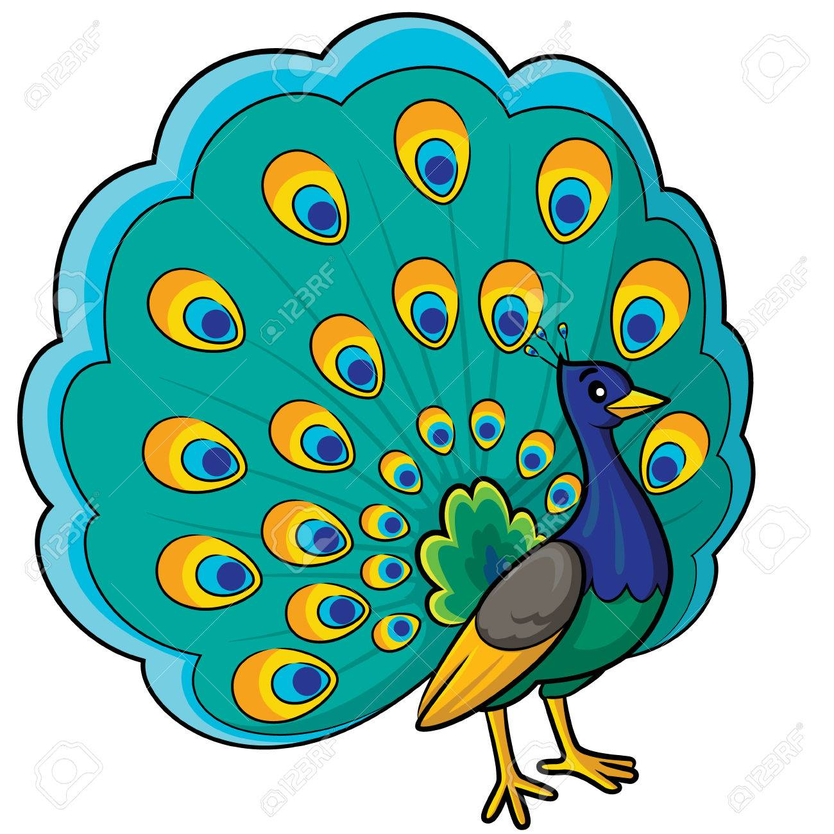
a python. a peacock.

7.  8. 
a monkey. a tiger.

Question 2: Fill in the blank with a suitable letter:
1. Slo_ly
2. Ro_r
3. Q_i_tl_
4. _yth_n
5. P_ac_c_
6. P_nd_
7. _ov_
8. L_u_ly
9. _o_ il_a
10. B_a_tif_ll_

Question 3: Read and match:
1. Where did you go yesterday? | a. Yes, I did. They were really noisy. | 1.
2. What did the lions do when you were there? | b. I saw a baby elephant and some other animals. | 2.
3. When did you go to the zoo? | c. They were big and moved slowly. | 3.
4. Who did you go with? | d. They roared loudly. | 4.
5. Did you see any monkeys? | e. Yes, the tigers were very fast. | 5.
6. What is the elephants like? | f. I went there at 8 a.m. | 6.
7. What did you see at the zoo? | g. By bus. | 7.
8. Did you go to the zoo last weekend? | h. No, I didn’t. | 8.
9. How did you get there? | i. I went there with my classmates. | 9.
10. Did you see any tigers? | j. I went to the zoo. | 10.

Question 4: Put the words in correct order:
1. Did/ week/ you/ to/ the/ go/zoo/,/ Phong/ last/?
............................................................................................
2. did/ the/ do/ What/ when/ you/ there/ peacocks/ were/?
............................................................................................
3. pandas/ saw/ two/ at/ the/ She/ zoo/.
............................................................................................
4. are/ the/ your/ zoo/ favourite/ animals/ What/ at/?
.............................................................................................
5. moved/ The/ python/ slowly/ really/ and/ quietly/.
.............................................................................................
6. The/ slowly/ pandas/ really/ things/ cute/ were/ and/ did/.
..................................................................................................
7. The/ was/ moved/ quickly/ gorillas/ Nam/ at/ the/ when/ zoo/.
...................................................................................................
8. Hung/ circus/ the/and/ I/ a/ saw/ lot/ animals/ of/in/.
...................................................................................................
9. Mai/ fast/ the/ because/ tigers/ they/ liked/were/.
...................................................................................................
10. The/ down/ monkeys/ up/ and/ very/ jumped/quickly/.
.....................................................................................................

Question 5: Read and complete:
A) bus – what – animals – zoo – how – where
1.................................. did you go last week?
2. I went to the ..................................
3. ................................. did you go to the zoo?
4. I went there by ................................. .
5. ................................. did you see at the zoo?
6. I saw a lot of ................................. .

B) like – go – big – slowly – zoo – animals
A: I didn’t see you yesterday. Where did you (1) ................................. ?
B: I went to the (2) ..................................
A: What did you see there?
B: I saw some (3) .................................. I enjoyed looking at the baby elephant.
A: What was it (4) .................................?
B: It was very (5) ..................................
A: What did it do when you were there?
B: I t moved (6) ................................. and quietly.

TRAN CAO VAN PRIMARY SCHOOL  CLASS: 5/………………  NAME: …………………………………………. | English test  Time: 30 minutes  Test 2.

Question 1: Look and read. Put a tick (√) or a cross (X) in the box as examples.
0. 00.
It is a book . √ Open your book, please. X

1.  2. 
football. basketball

3.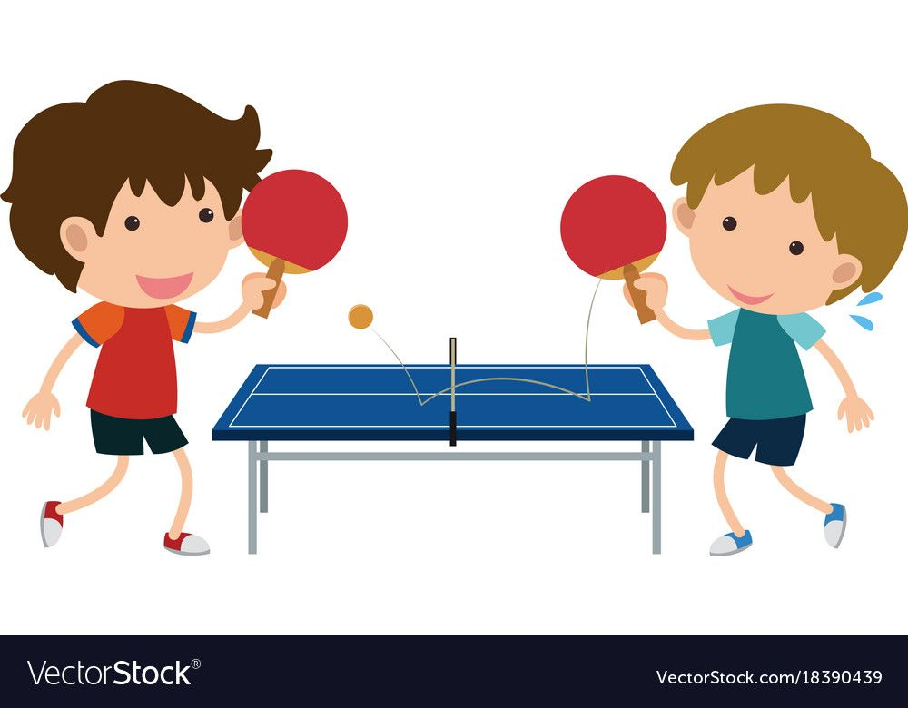 4.
volleyball table tennis

5. 6. 
Sports Day Teachers’ Day.

Question 2: Choose the correct answer.
1. _________ will Sports Day be?
a. When
b. Where
c. Why
d. Which
2. What song are you going to _________ in the contest?
a. draw
b. play
c. show
d. sing
3. When will Teacher’s Day be? – ____________
a. It’ll be in Saturday
b. It’s on Saturday
c. It’ll be on Saturday
d. It be on Saturday
4. ___________? – They are going to play football.
a. Where are they?
b. When are they going to play football?
c. What are they going to do on Sport Day?
d. What do they going to do on Sport Day?
5. Today is Thursday. Tomorrow is __________
a. Sunday
b. Friday
c. Saturday
d. weekend
6. Are they excited about Sport Day? – ________
a. Yes, they do
b. Yes, they aren’t
c. No, they don’t
d. Yes, they are
7. ________ you play football or basketball on Sport Day?
a. Are
b. Do
c. Will
d. Were
8. Will the Singing Contest on _________ of September.
a. twice
b. two times
c. two
d. the second
9. ________ Linda and Ngoc going to play table tennis on the Sport Day?
a. Are
b. Is
c. Will
d. Do
10. When will _________ be?
a. Teacher Day
b. Teachers Day
c. Day’s Teacher
d. Teachers’ Day
11. What are Nhung and Lan going to do on Sport Day? – ________
a. They will play basketball
b. They are going to play basketball
c. Sure
d. They love play basketball
12. Will Nana’s sister ________ the Drawing Contest?
a. take place
b. participant
c. take part
d. take part in
13. 2/9 is Vietnamese _________
a. Independence Day
b. Children’s Day
c. Sport Day
d. Teachers’ Day
14. Will you take part in Sports Day? – __________
a. Yes, I won’t
b. Yes, I am
c. Yes, I do
d. Sure
15. Are you going to play table tennis on Sports Day?
a. Yes, I do
b. No, I am
c. No, I won’t
d. Yes, I am
16. The children give flowers and ________ to teachers on Teachers’ Day.
a. badminton
b. presents
c. nothing
d. chess
17. ________ badminton.
a. Let play
b. Let’s playing
c. Let’s to play
d. Let’s play
18. What’s your ___________ sport? – It’s football.
a. favourite
b. like
c. best
d. love
19. They _________ for Sports Day now.
a. is practising
b. are practising
c. do practise
d. will practising
20. _______ Phong going to do on Sport Day?
a. What’re
b. When’s
c. What’s
d. What does
Question 3: Put the words in the correct order.
1. is/ Teachers’/ Day/ today/ our
2. the/ are/ Lan/ in/ room/ and/ Nga/ singing
3. When/ will/ the/ singing/ contest/ be/?
4. stadium/ school/ is/ a/ our/ near/ there
5. teachers/ Day/ give/ flowers/ we/ the/ and/ cards/ to/ on/ Teachers’
6. Nam/ Minh/ going/ do/ are/ and/ to/ football/ play.
7. Sumo/ national/ Japan’s/ is/ sport
8. Jame/ but/ she/ loves/ badminton/ doesn’t/ it/ playing/ play/,
9. last/ festival/ had/ school/ sports/ my/ Sunday/ a.
10. you/ play/ will/ next/ hide and seek/ Saturday/?
11. the/ classmates/ music/ take/ in/ event/ will/ my/ part

Question 4: Read and complete. Then say the sentences aloud.
football do be what sing Saturday

- A: When will Sports Day_______ ?
B: It’ll be on_______ .
2. A: What will they_______ on Children’s Day?
B: They’ll play_______.
3. A: _______are they going to do on Independence Day?
B: They’re going to_______ songs.

Question 5: Read and complete
where will play when what

Phong: It’s not long until Sports Day!
It’ll be great!
Tony: (1)______ will it be?
Phong: On Saturday.
Tony: (2)______ will it be?
Phong: In the sports ground near our school.
Tony: (3)______ are you going to do on Sports Day?
Phong: Nam, Tom and I are going to
(4)_______ football. Our class will play against Class 5B.
Tony: I hope that you (5)______ win.
Phong: Me too!

Question 6:Complete the sentences. Use the correct forms of the verbs in brackets.
1. Nga and Hoa are________ badminton in the gym now. (play)
2. I will________ part in the music competition on Teachers’ Day. (take)
3. Tony will_______swimming. (go)
4. Tom will ________English songs. (sing)
5. They are________hard for the singing contest. (practise)

ĐÁP ÁN ĐỀ 1

Question 1: Look and read. Put a tick (√) or a cross (X) in the box.

1 | 2 | 3 | 4 | 5 | 6 | 7 | 8
√ | X | X | √ | √ | √ | X | X

Question 2:
1. slowly | 2. roar | quitely | 4. Python | 5. Peacock
6. Panda | 7. move | 8. loudly | 9. Gorilla | 10. Beautifully

Question 3:
1 - j; 2 - d; 3 - f; 4 - i; 5 - a; 6 - c; 7 - b; 8 - h; 9 - g; 10 - e
Question 4:
1 - Did you go to the zoo last weekend, Phong?
2 - What did the peacocks do when you were there?
3 - She saw two pandas at the zoo.
4 - What are your favorite animals at the zoo?
5 - The python moved really slowly and quietly.
6 - The pandas were really cute and did things slowly.
7 - The gorillas moved quickly when Nam was at the zoo.
8 - Hung and I saw a lot of animals in the circus.
9 - Mai liked the tigers because they were fast.
10 - The monkeys jumped up and down very quickly.

Question 5:
- 1 - Where; 2 - zoo; 3 - How; 4 - bus; 5 - what; 6 – animals
- 1 - go; 2 - zoo; 3 - animals; 4 - like; 5 - big; 6 - slowly

ĐÁP ÁN ĐỀ 2

Question 1: Look and read. Put a tick (√) or a cross (X) in the box.

1 | 2 | 3 | 4 | 5 | 6 | 7 | 8
√ | √ | X | X | X | X | X | X

Question 2:
1A 2D 3C 4C 5B 6D 7C 8D 9A 10D
11B 12D 13A 14D 15D 16B 17D 18A 19B 20C

Question 3:
- Today is our Teachers’ Day.
- Nga and Lan are singing in the room.
- When will the singing contest be?
- There is a stadium near our school.
- We give flowers and cards to the teachers on Teachers’ Day.
- Nam and Minh are going to play football.
- Sumo is Japan’s national sport.
- Jame loves playing badminton, but she doesn’t play it.
- My school had a sports festival last Sunday.
- Will you play hide and seek next Saturday?
- My classmates will take part in the music event.

Question 4:

1. Be, Saturday
2. Do, football.
3. What, sing

Question 5:
1. When
2. Where
3. What
4. Play
5. Will
Question 6:
1. Playing
2. Take
3. Go
4. Sing
5. Practising

