**ĐỀ KIỂM TRA 1**

***Question 1: Look and read. Put a tick (✓) or a cross (x) in the box.***

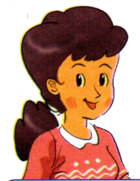 **☒ 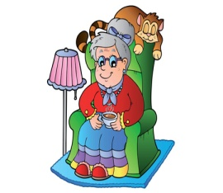 ☑**

0. This is my father. 00. This is my grandmother.

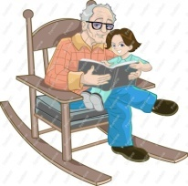 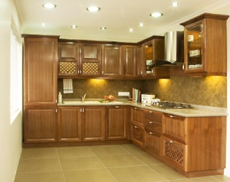

1. He is my grandfather. 2. There are two kitchens in my house.

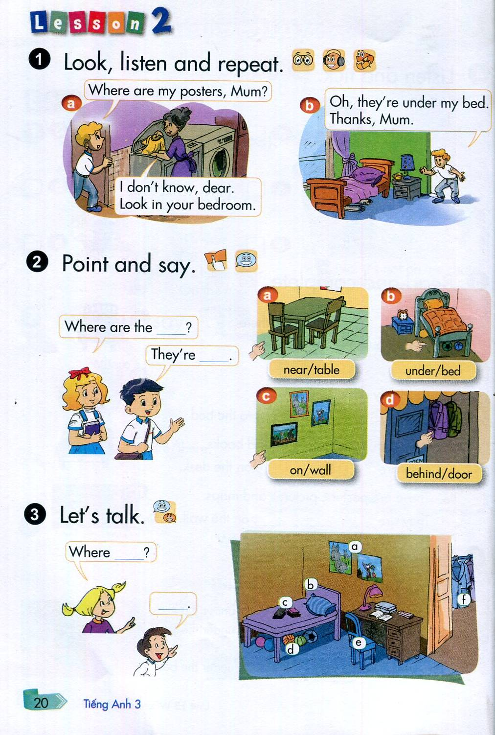

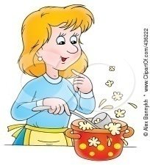

3. My mother is cooking. 4. It is a chair.

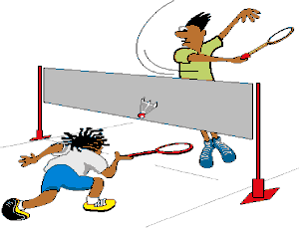 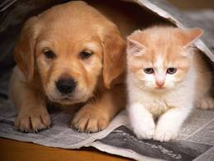

5. They are playing badminton. 6. There are two cats.

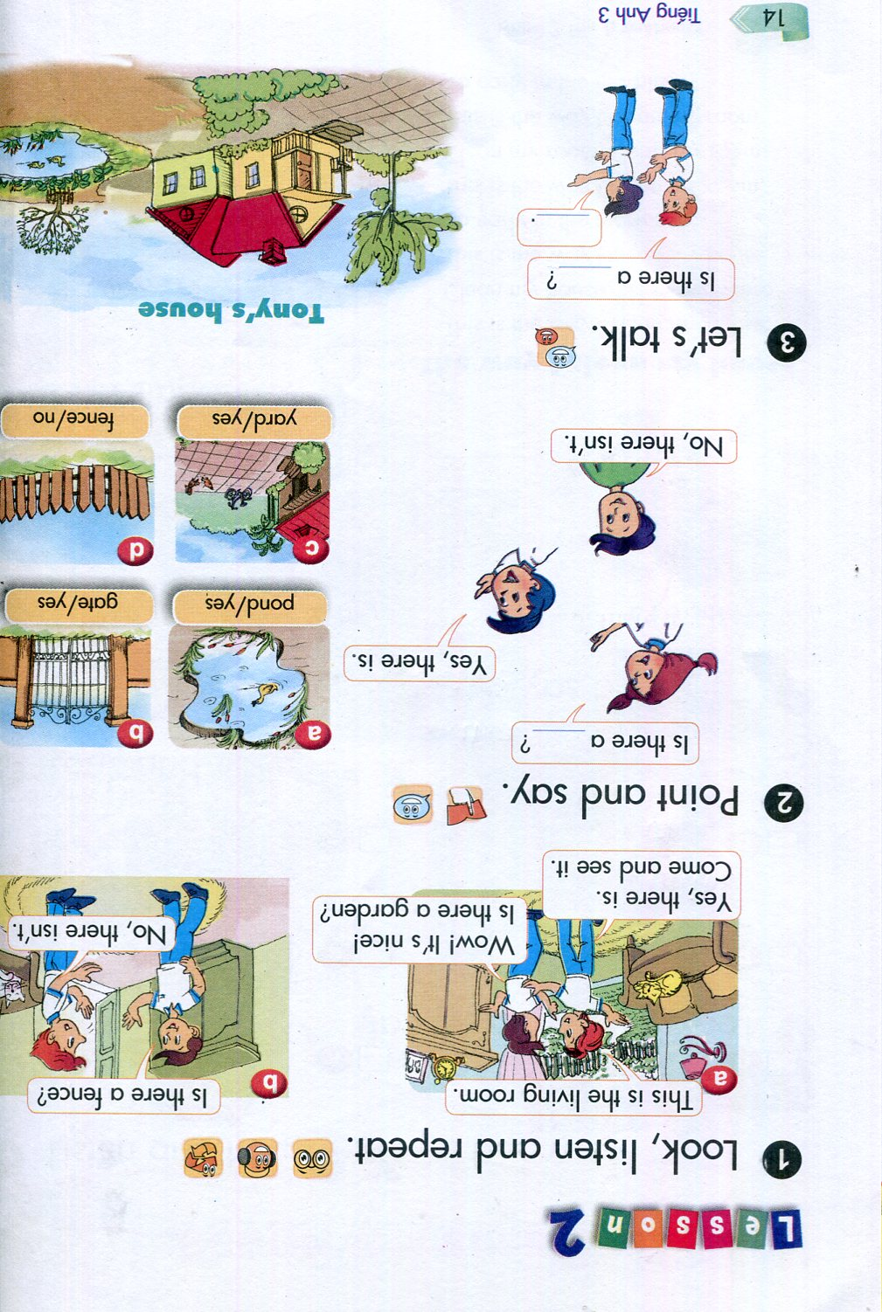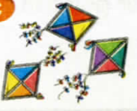

7. I like kites. 8. This is a fence.

***Question 2: Look and read. Write Y (Yes) or N (No) as examples.***

0.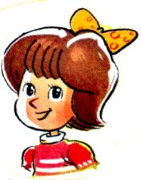 Her name is Mary. **Y**

00. Description: MC900359587[1] That’s a book. **N**

1. 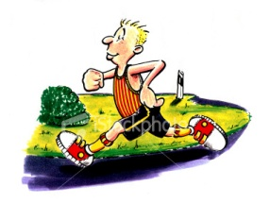 He’s cycling. ___________

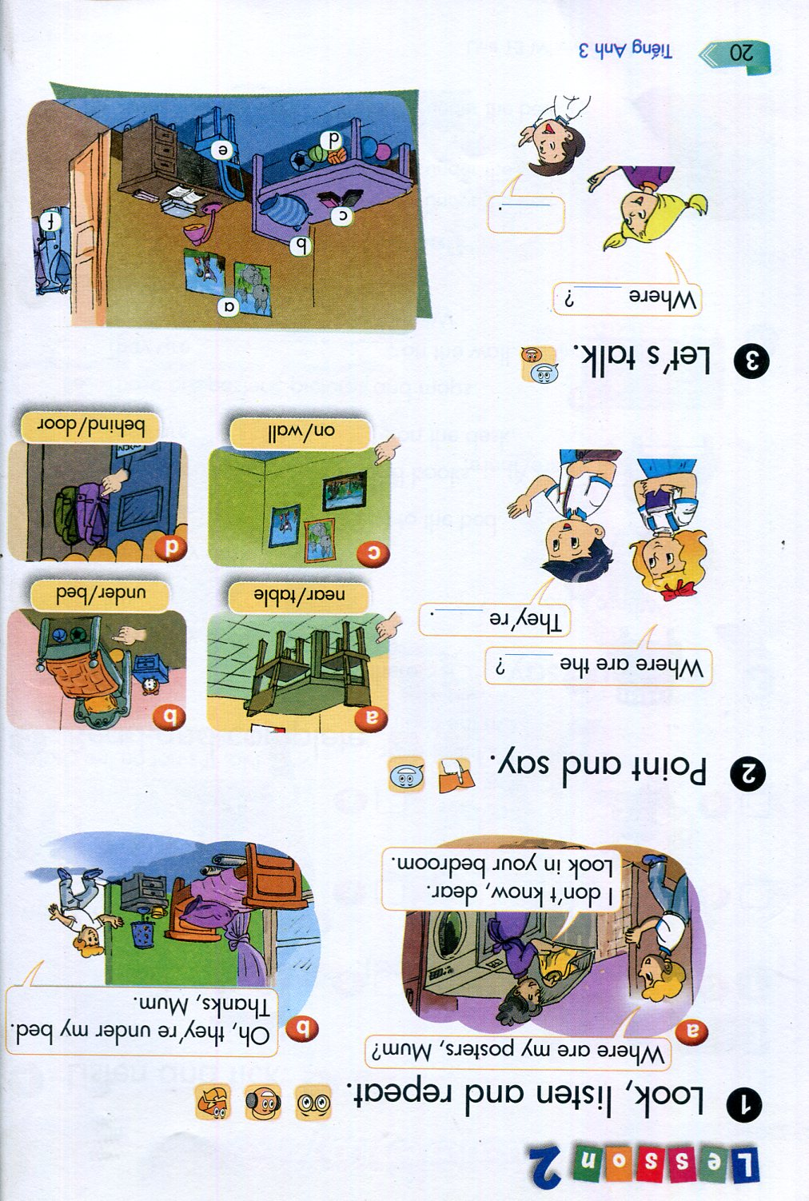

2. The chairs are next to the table ___________

3. 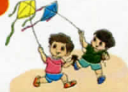 They are playing football. ___________

4. 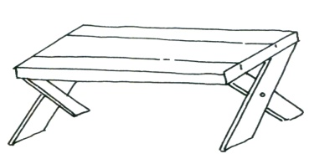 The balls are on the table. ___________



5. 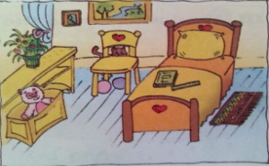 There’s a bedroom in my house. ___________

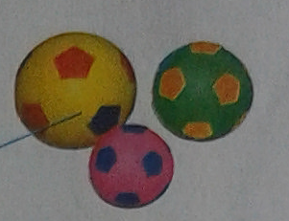

6. My friend has three balls. ___________

7. There is a garden. ___________

8. 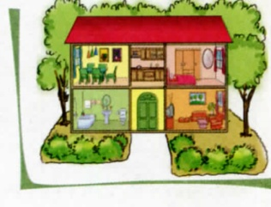 This is my school. ___________

***Question 3: Look at the pictures and the letters. Write the words.***

Example: 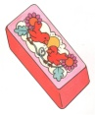 berbur rubber

1. 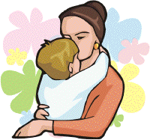 otrehm

2. 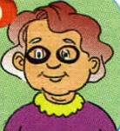 mgodrantehr

3. 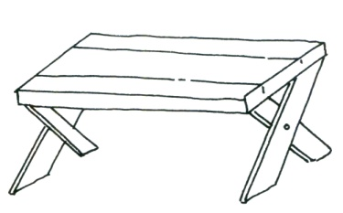 duren



4. 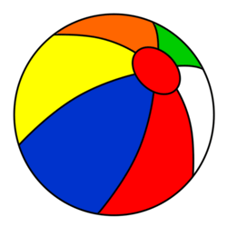 blal

5. 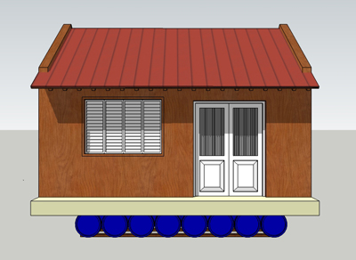 sohue ___________

***Question 4: Put the word in order.***

1. brother/ old/ my/ fifteen/ is / years

--------------------------------------------------

2.his/ is/ young/ mother

--------------------------------------------------

3.there/ is/ yard/ in front of/a/ house/ the

--------------------------------------------------

4.fence/is/ colour/her/what?

--------------------------------------------------

***Question 5: Read and complete the sentences.***

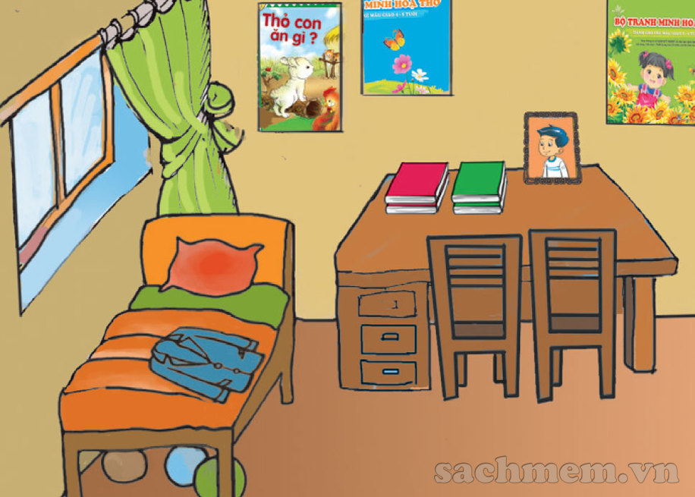

Hello! My name is Quan. Here is a picture of my room.

This is my bed. My coat is on the bed. There are three

balls under the bed. There are two chairs near the desk.

There are four books and a photo on the desk. There

are three posters on the wall.

1. My coat is ___________________________.

2. There are three_____________________ under the bed.

3. There are _________________ chairs.

4. The posters are ___________________________.

**Question 6: Read the passage and circle the correct answers.**

Hello! My name is John and this is my house. There is a living room, a kitchen, two bedrooms and two bathrooms. There is a yard in front of the house. The garden is behind the house. It is very beautiful with many flowers and big trees. My father makes white fence around the house.

1.How many rooms are there in John’s house?

A. 6 B. 7 C. 8

2. Which is in front of John’s house?

A. The garden B. The yard C. The fence

3. Is there a black fence around the house?

A. No, it isn’t. B. Yes, there is. C. No, there isn’t.

**************The end *************

**ĐỀ KIỂM TRA 2**

***Question 1: Look and read. Put a tick (✓) or a cross (x) in the box. (2ms)***

0. It’s rainy.

**✓✓🗶🗶**

 00. She’s ten years old.

**🗶**

 1. There’s a goldfish in the fish tank.

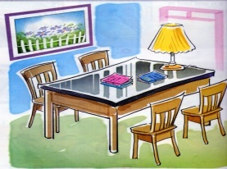 2. This is my bedroom.

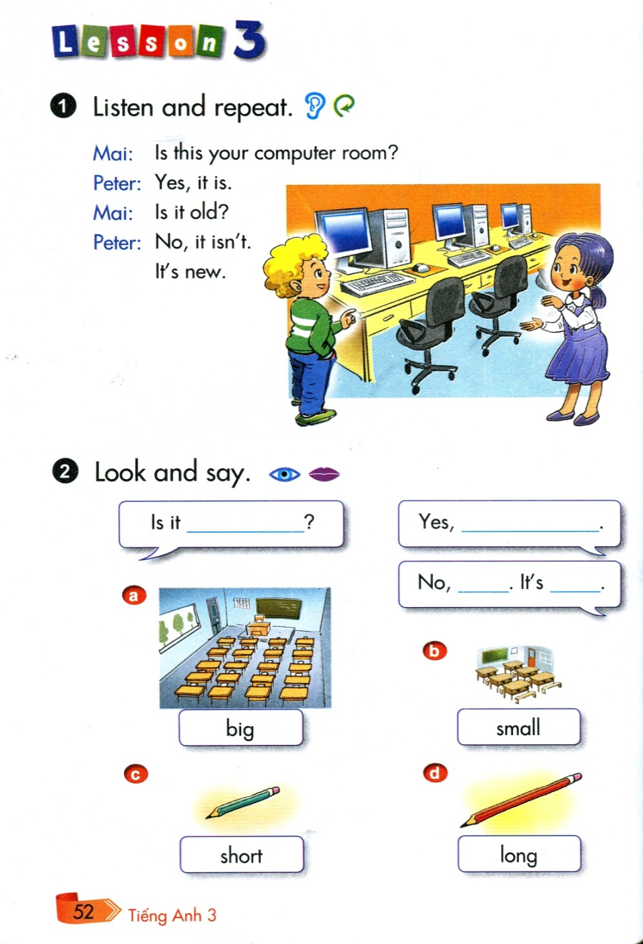

3. They are playing football.

4. I don’t have a dog. I have a nice cat.

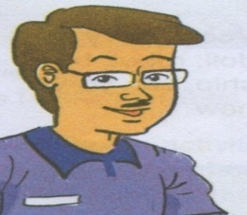 5. He’s my father. I call him daddy.

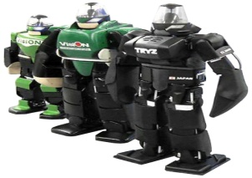 6. I like dolls.

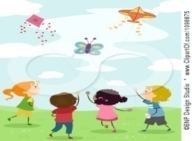 7. They are flying kites.

 8. It’s cloudy today.

***Question 2: Look and read. Write Y (Yes) or N (No) as examples. (2ms)***

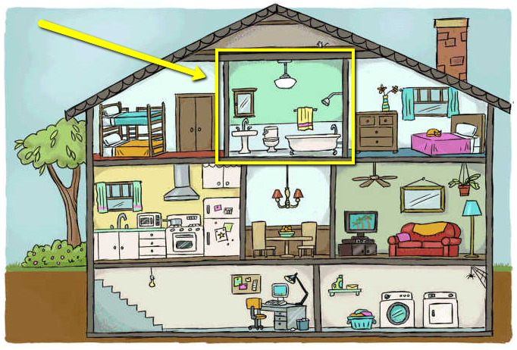

**Neeeeeees**

1. This is a classroom.

**Y**

1. This is a house.

1. There are eight rooms in the house.

2. There’s a kitchen in the house.

3. There are three living rooms in the house.

4. There are two bedrooms.

5. There’s a dining room. It’s very nice.

6. There are two bathrooms in the house.

7. The house is small but nice.

8. The tree is next to the house.

***Question 3: Look at the pictures and the letters. Write the words. (3ms)***

Example: 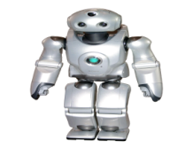 orotb robot

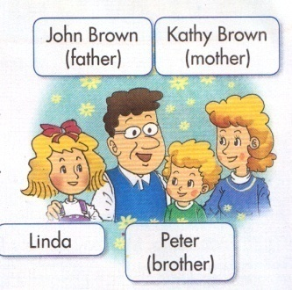

1. laifmy

2. 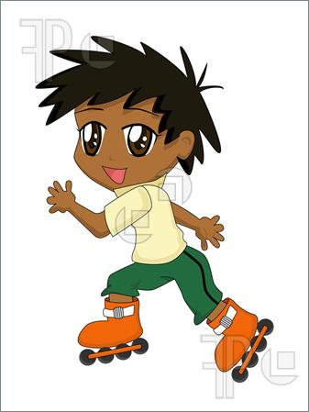 ingstak

3. 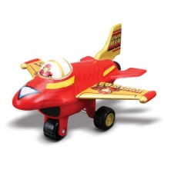 alpen

4. 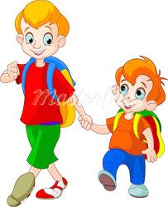 rotberh

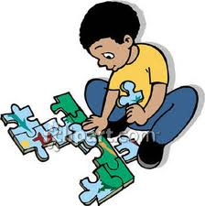

5. zezupl

6. 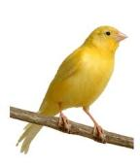 drib ___________

***Question 4: Choose the word from the box and write it next to the numbers from 1 to 6 (3ms).***

listening, is, watching, in, book, playing, name, singing

My (0) **name** is Linda. Today my family (1) ___________ at home. We are (2) ___________ the living room. My grandfather is (3) ___________ TV. My father is reading a (4) ___________. My grandmother and mother are

(5) ___________ to music. My brother is (6) ___________ the piano. And I am singing. We are very happy.

**************The end *************

**ĐỀ TRẮC NGHIỆM**

**1. Hello Peter. _______ Mai.**

**A. I**

**B. Am**

**C. I’m**

**D. You**

**2. _______ to meet you, Mai.**

**A. Fine**

**B. Nine**

**C. Nice**

**D. Good**

**3. _______ are you? - I’m fine. Thanks.**

**A. What**

**B. How**

**C. Who**

**D. And**

**4. What’s _______ name? - I’m Linda.**

**A. your**

**B. you**

**C. my**

**D. I**

**5. How _______ you spell your name? - L-I-N-D-A.**

**A. is**

**B. are**

**C. am**

**D. do**

**6. Is that Tony? - No, it _______.**

**A. is**

**B. are**

**C. ’s**

**D. isn’t**

**7. _______ that? - It’s Mr. Loc.**

**A. Who**

**B. Who’s**

**C. What**

**D. What’s**

**8. My _________ is Tony.**

**A. name**

**B. name’s**

**C. school**

**D. classroom**

**9. Are they your friend? - Yes, _______ are.**

**A. he**

**B. they**

**C. I**

**D. she**

**10. _______ quiet, please!**

**A. Be**

**B. Come**

**C. Sit**

**D. Stand**

**11. Circle the odd one out:**

**A. Chess**

**B. Football**

**C. Table tennis**

**D. Music room**

**12. May I go out? - Yes, you _______.**

**A. are**

**B. can**

**C. can’t**

**D. aren’t**

**13. Look at my school. _______ is beautiful.**

**A. They**

**B. He**

**C. It**

**D. She**

**14. _______ is your school bag? - It’s brown.**

**A. What**

**B. How**

**C. Who**

**D. What colour**

**15. These are my _______.**

**A. pencils sharpeners**

**B. pencils sharpener**

**C. pencil sharpeners**

**D. pencil sharpener**

**16. What do you do at break time? - I _______ table tennis.**

**A. play**

**B. do**

**C. skip**

**D. skate**

**17. _______ you like badminton? - No, I don’t.**

**A. Are**

**B. Is**

**C. Can**

**D. Do**

**18. I _______ like chess. I like skating.**

**A. am**

**B. don’t**

**C. am not**

**D. can’t**

**19. _______ those your books? - Yes, they are.**

**A. Is**

**B. Do**

**C. Are**

**D. Can**

**20. Is this your _______ 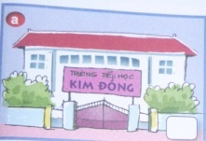 ? - Yes, it is.**

**A. classroom**

**B. computer room**

**C. library**

**D. school**

**21. ________ you like skating at break time? - No, I don’t.**

**A. Are**

**B. Can**

**C. May**

**D. Do**

**22. What do you do at break time? - I play _______ .** 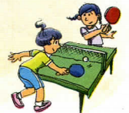

**A. badminton**

**B. basketball**

**C. chess**

**D. table tennis**

**23. What do they do at break time? - They play _______ .** 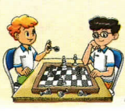

**A. badminton**

**B. basketball**

**C. chess**

**D. table tennis**

**24. Do they _______ at break time? - Yes, they do.** 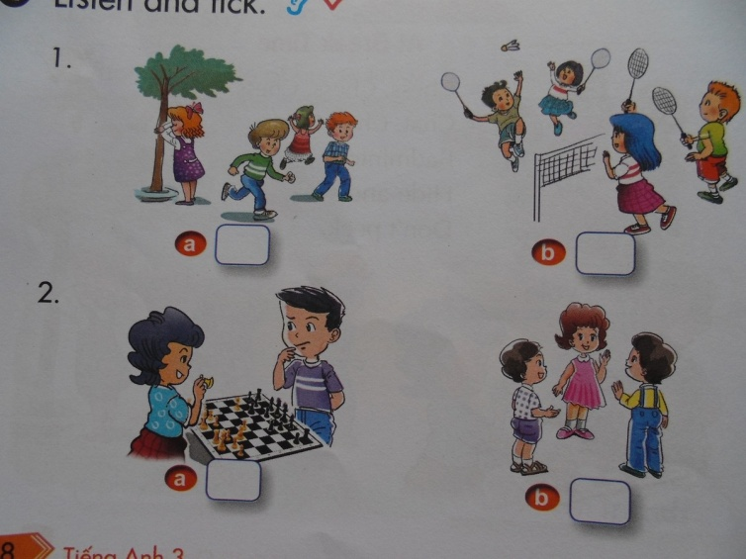

**A. play hide-and-seek**

**B. play blind man’s bluff**

**C. skip**

**D. play badminton**

**25. Is this your ruler? - No, it _________.**

**A. is**

**B. are**

**C. aren’t**

**D. isn’t**

**26. _________ your book, please!** 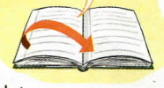

**A. Close**

**B. Open**

**C. Sit**

**D. Stand**

**27. That is my ___________.** 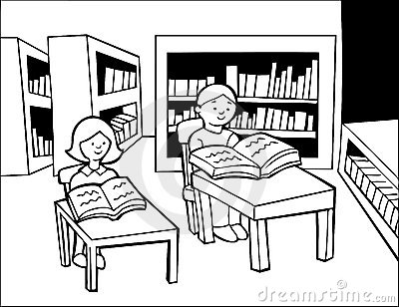

**A. computer room**

**B. gym**

**C. library**

**D. classroom**

**28. Who’s that? - It’s ___________.** 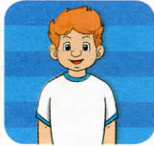

**A. Mary**

**B. Linda**

**C. Mai**

**D. Tony**

**29. What do you do ___________ break time?**

**A. at**

**B. in**

**C. on**

**D. with**

**30. _________ ? - It’s Mai.**

**A. Who’s that**

**B. How do you spell your name**

**C. How old are you**

**D. How are you**

**31. How old are you? - I’m _________.** 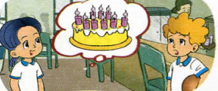

**A. six**

**B. seven**

**C. eight**

**D. nine**

**32. _________ your friends? - Yes, they are.**

**A. Are they**

**B. They are**

**C. Is she**

**D. Is he**

**33. _________ I come in, Mr Loc? - Yes, you can.**

**A. Do**

**B. May**

**C. Am**

**D. Are**

**34. My _________ is new.** 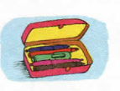

**A. bag**

**B. book**

**C. pencil case**

**D. backpack**

**35. What do you do at break time? - I play _________.** 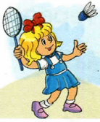

**A. chess**

**B. hide-and-seek**

**C. table tennis**

**D. badminton**

**36. Do you like _________? - Yes, I do.** 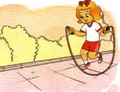

**A. skipping**

**B. playing hide-and-seek**

**C. playing table tennis**

**D. playing badminton**

**37.** 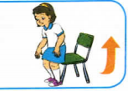

**A. Sit down, please.**

**B. stand up, please.**

**C. Open the door, please.**

**D. Close the door, please.**

**38. What are _________? - They are pens.** 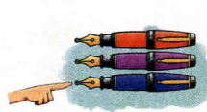

**A. this**

**B. that**

**C. these**

**D. those**

**39. What are _________? - They are pencil cases.** 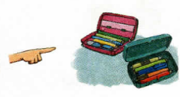

**A. this**

**B. that**

**C. these**

**D. those**

**40. I like playing ________ at breaktime.** 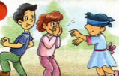

**A. hide-and-seek**

**B. blind man’s bluff**

**C. football**

**D. table tennis**

**41. What are these? - They are _______** 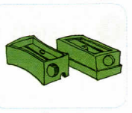

**A. pens**

**B. pencils**

**C. pencil sharpeners**

**D. rubbers**

**42. Do you like basketball? No, I _________.**

**A. do**

**B. am not**

**C. don’t**

**D. like**

**43. Is that your school bag? - _________**

**A. Yes, it is.**

**B. Yes, they are.**

**C. Yes I am.**

**D. Yes, I do.**

**44. Is _________ your school bag? - No, it isn’t.** 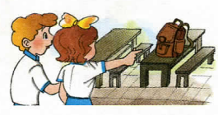

**A. this**

**B. that**

**C. these**

**D. those**

**45. _______ , please! 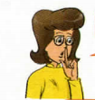.**

**A. Come here**

**B. Don’t talk**

**C. Stand up**

**D. Open your book**

**46. May I _________? - Yes, you can.** 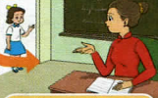

**A. come in**

**B. go out**

**C. stand up**

**D. sit down**

**47. How old are you? - _______**

**A. I’m six.**

**B. I’m six year old.**

**C. I six.**

**D. I six years old.**

**48. _________? - Fine. Thanks.**

**A. How old are you**

**B. What’s your name**

**C. How do you spell your name**

**D. How are you**

**49. Are Peter and Mary your friends? - Yes, _________.**

**A. I am**

**B. They are**

**C. She is**

**D. He is**

**50. May I come in? - _________** 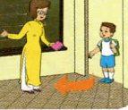

**A. Yes, you can’t.**

**B. No, you can’t.**

**C. Yes, you can.**

**D. No, you can.**

**51. How old are you?**

**A. I’m nine**

**B. I’m nice**

**C. I’m fine**

**D. Im nine**

**52.How old is your father?**

**A. She’s forty**

**B. He’s fourty**

**C. She is fourty**

**D. He’s forty**

**53. Is she fifteen years old?**

**A. Yes, it is**

**B. No, it isn’t**

**C. Yes, she is**

**D. No, she is**

**54.Is there a yard in front of the house?**

**A. Yes, it is**

**B. No, it isn’t**

**C. Yes,there are**

**D. Yes, there is**

**55. Are there two beds in the bedroom?**

**A. No, there aran’t**

**B. No, there aren’t**

**C. Yes, they are**

**D. No, they aren’t**

**56. How many rooms in your house?**

**A. five room**

**B. fif rooms**

**C. five rooms**

**D. fine rooms**

**57. Do you like your bedroom?**

**A. Yes, I do**

**B. No, I do**

**C. Yes, I does**

**D. Yes, I don’t**

**58. Does Nam like his house?**

**A. Yes, She does**

**B. Yes, He do**

**C. No, He doesn’t**

**D. No, She doesn’t.**

**59. Are they your parents?**

**A. Yes, there are**

**B. Yes, these are**

**C.Yes, they are**

**D. Yes,it is**

**60. How……….bathrooms in her house?**

**A. much**

**B. old**

**C. long**

**D. many**

Đáp án ĐỀ 1

***Question 1: Look and read. Put a tick (✓) or a cross (x) in the box.***

**1.☑ 2. ☒ 3. ☑ 4. ☒ 5. ☑ 6. ☒ 7. ☑ 8. ☑**

***Question 2: Look and read. Write Y (Yes) or N (No) as examples.***

1. **N 2. Y 3. N 4. Y 5. Y 6. Y 7. N 8. N**

***Question 3: Look at the pictures and the letters. Write the words.***

**1. mother 2. grandmother 3. under 4. ball 5. House**

***Question 4: Put the word in order.***

***1.My broter is fifteen years old.***

***2.His mother is young.***

***3.There is a yard in front of the house.***

***4.What colour is her fence?***

***Question 5: Read and complete the sentences.***

1. ***on the bed***
2. ***balls***
3. ***two***
4. ***on the wall***

**Question 6: Read the passage and circle the correct answers**

***1.A 2.B 3.C***

Đáp án ĐỀ 2

***Question 1: Look and read. Put a tick (✓) or a cross (x) in the box.***

**1.☑ 2. ☒ 3. ☑ 4. ☒ 5. ☑ 6. ☒ 7. ☑ 8. ☑**

***Question 2: Look and read. Write Y (Yes) or N (No) as examples.***

**1.Y 2. Y 3. N 4. Y 5. Y 6. N 7. N 8. Y**

***Question 3: Look at the pictures and the letters. Write the words.***

**1. family 2. skating 3. plane 4. brother 5. puzzle 6. bird**

***Question 4: Choose the word from the box and write it next to the numbers from 1 to 6***

**(1) is (2) in (3) watching (4) book (5) listening (6) playing**

**ĐÁP ÁN ĐỀ TRẮC NGHIỆM**

**1C 2C 3B 4A 5D 6D 7B 8B 9B 10A 11D 12B 13C 14D 15C 16A 17D 18B 19C 20D 21D 22D 23C 24A 25D 26B 27C 28D 29A 30A 31D 32A 33B 34C 35D 36A 37B 38C 39D 40B 41C 42C 43A 44B 45B 46A 47A 48D 49B 50C 51A 52D 53C 54D 55B 56C 57A 58C 59C 60D.**